DBMS

LAB – QUIZ

**NAME :** SANMAT SANJAYAKUMAR PAYAGOUDAR

**SRN :** PES1UG20CS385

**SET 1.**

**DATA BASE Creation :**

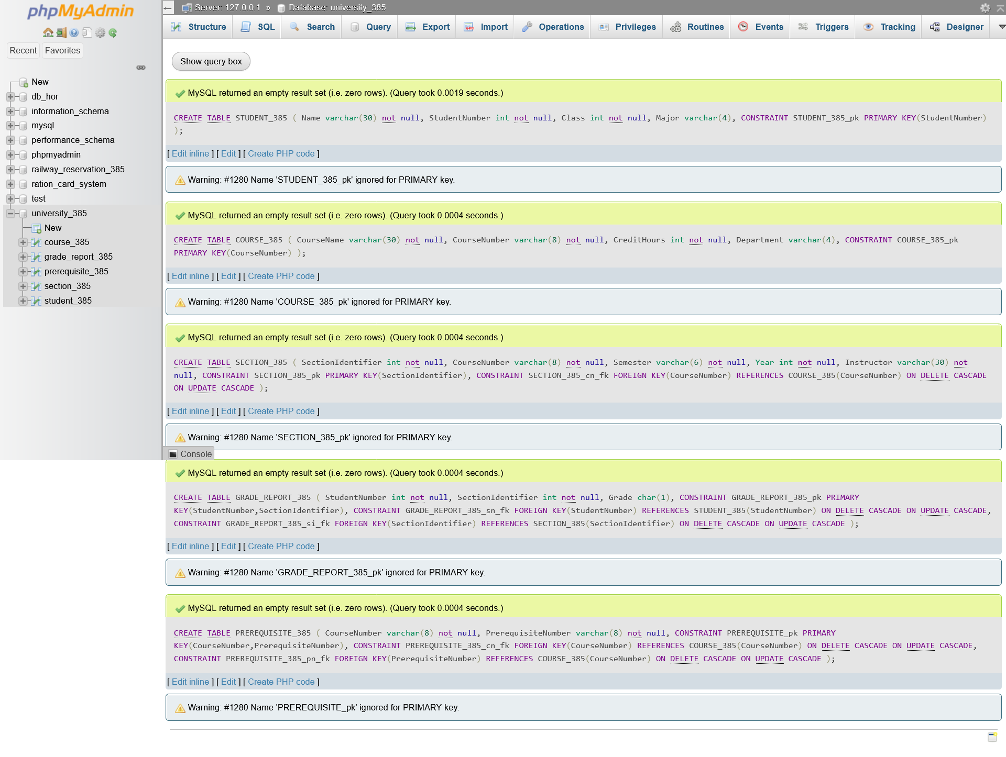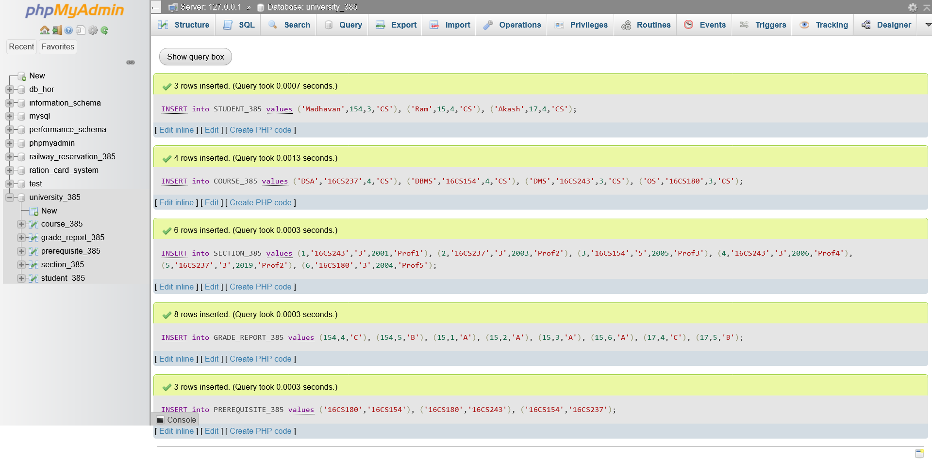

1. Query :

SELECT CourseName FROM COURSE_385 JOIN SECTION_385 ON COURSE_385.CourseNumber = SECTION_385.CourseNumber WHERE SECTION_385.Year BETWEEN "2001" AND "2004";

Output:

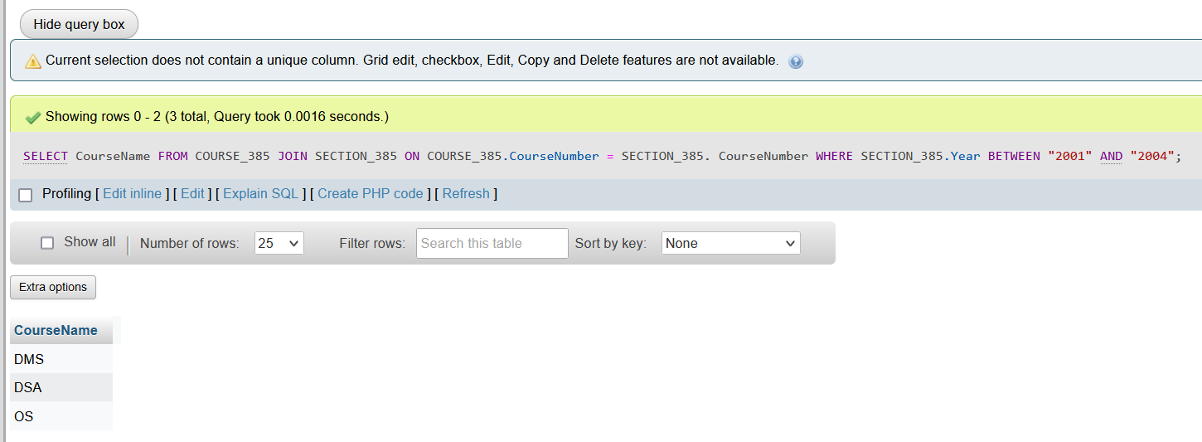

1. Query :

create table Student_Report_385 as select StudentNumber, CourseNumber, case

when Grade = 'A' then 100

when Grade = 'B' then 90

when Grade = 'C' then 80

end as Marks

from grade_report_385 natural join section_385 natural join COURSE_385

Output:

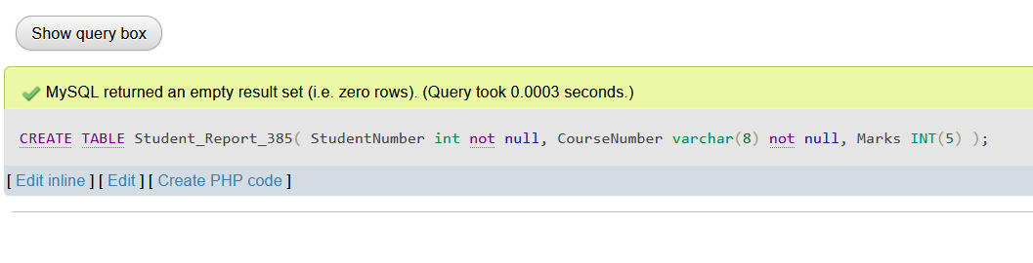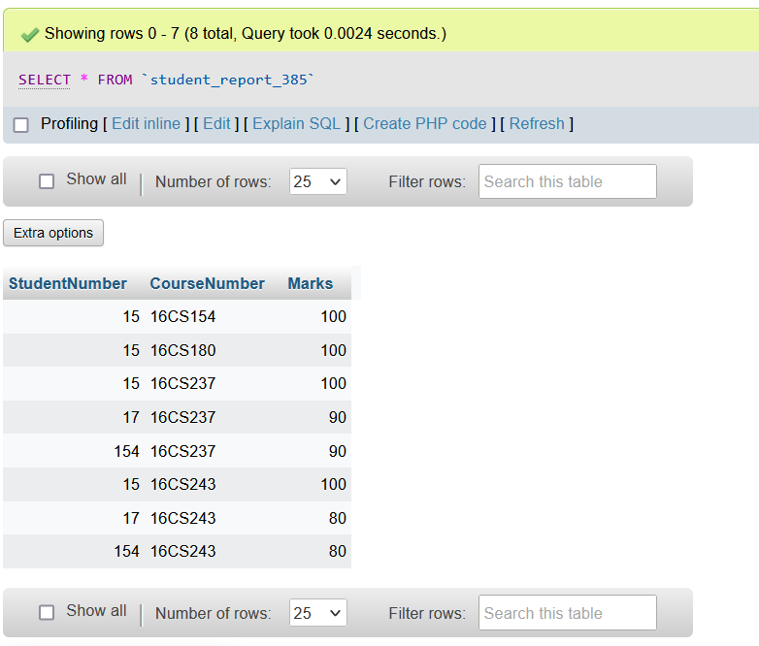

1. Query :

create table student_statistics_385(

totalmarks int not null,

avgmarks int not null

);

delimiter //

create trigger save_current_total_avg

after insert

on Student_Report_385 for each row

begin

    insert into student_statistics_385(totalmarks, avgmarks)

    select sum(marks), (sum(marks) / count(*))

    from Student_Report_385;

end//

delimiter ;

Output :

